Spring Performance 2018
Make-up, Costume & Hair Requirements for Dancers

Make-up Requirements:

- Each child should have their own make-up case & mirror, with their name on it!
- Apply make-up at home before arriving.
- Bring make-up case with you for re-application at the theater.

Costume & Hair Requirements:

Please read carefully and note that you may need to purchase specific items
for you/your child’s role. Do not delay as the performance is approaching rapidly.

- All ballet shoes must be LEATHER, clean and have proper elastics sewn across the insteps.
- Strings must be tied and tucked in.
- Tights must be clean and run free.
- Always have an additional pair ready in case of a run or a snag.
- Please purchase the brands listed, including the specific colors and style so the dancers are uniform.
- If you wear a nude leotard under your costume, make sure the straps are securely attached to the costume. NO clear plastic straps should be used.
- Dancers may NOT wear jewelry (unless requested by the choreographer for a particular piece).
- Underpants should NOT be worn under leotards.
- Please have hair slicked back away from the face with hairspray or gel; NO wisps or bangs.
- Hair should be secured in a bun with hairnets and plenty of bobby pins that match hair color. Do not use any clips or barrettes.
- If your child has short hair, please have the front pulled back & secured away from the face.
*****Tights, camisoles, dance shoes and apparel can be found at
Dancer’s Outlet in East Lyme 860 367-1491*****

“BARN DANCE” Ballet- Ms. Marylu, Ms. Laura

MAKEUP: All Ballet Classes - Apply Blush, Lipstick & Mascara. Darken fair haired eyebrows with eyeliner pencil.
Character 3/4 - Full stage make-up.

TIGHTS: Capezio tights in Ballet Pink OR Body Wrappers in Theatrical Pink.

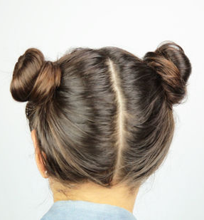
SHOES: All Ballet Classes - Pink Ballet flats.
Character 3/4 - dancers will wear black character shoes

HAIR: Chicks, Cows, Scarecrows: Medium/High bun with no part. Matching hair colored hairnet. NO BANGS
Horses: Very high bun on top of head. Matching hair colored hairnet. NO BANGS
Character 3/4: 2 pigtail, french braids. NO BANGS
Piglets: 2 pigtail buns. Matching hair colored hairnet. NO BANGS
PIGLETS
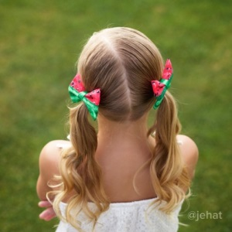
Farmers: 2 pigtails with curls. NO BANGS
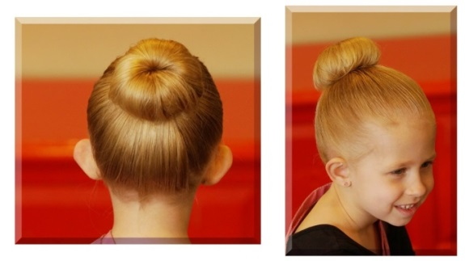
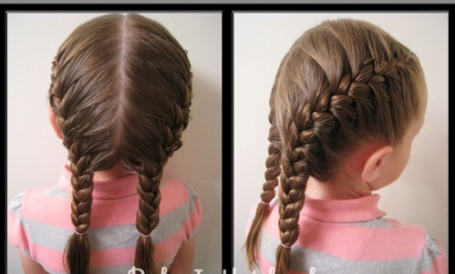

CHICKS, COWS, SCARECROWS
CHARACTER 3/4
HORSES
FARMERS

MODERN: - FULL STAGE MAKE-UP (Level 5, 6, 7 with Lashes)

Modern 4/5: Ms. Stephanie “Hlohonolofatsa”

TIGHTS: Capezio footless tights in Light Suntan. No underwear.

SHOES: Bare feet

HAIR: Medium-High Bun with no part. NO BANGS

Modern 6A/B: Ms. Bo- “PATTERNS & LANDSCAPES”
TIGHTS: Dancers are wearing a unitard. (Please speak with Ms. Bo about undergarments)

SHOES: Bare feet

HAIR: Med-high Bun with no part, NO BANGS

Modern 7: Ms. Bo- “. . . Like a Cloud, Like a Wing, Like a White Light Burning . . .”
TIGHTS: Capezio footless tights in Light Suntan. No underwear.

SHOES: Bare feet

HAIR: Medium-High Bun with no part, NO BANGS

Character 5/6A: Ms. Laura- “Czardas”
TIGHTS: Capezio Seamed tights in Ballet Pink OR Body Wrappers in Theatrical Pink. No underwear.

SHOES: Black Character Shoes

HAIR: Medium-High Bun with no part. NO BANGS

OTHER: Black character class skirts

LEVELS 1, 2, 3, 4- BALLET CLASS PIECES

MAKE-UP: Full Stage (No False Lashes)

TIGHTS: Capezio tights in Ballet Pink OR Body Wrappers in Theatrical Pink- No underwear.
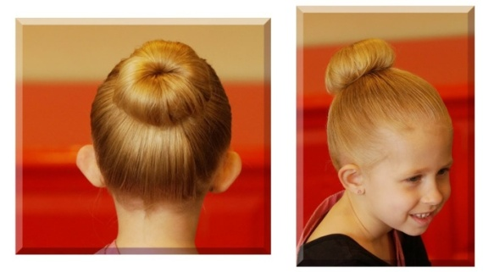
SHOES: Pink Leather Ballet flats.

HAIR: Medium-High Bun with no part. NO BANGS

LEVELS 5, 6A/B, 7- BALLET CLASS PIECES

MAKE-UP: Full Stage with Lashes

TIGHTS: Capezio Seamed tights in Ballet Pink OR Body Wrappers in Theatrical Pink. No underwear.

SHOES: Levels 5, 6A/B - Pink Leather Ballet flats. Level 7- Pink Pointe Shoes

HAIR: Medium-High Bun with no part. NO BANGS

COMPANY Pieces- Serenade, Delibes Variations

FULL STAGE MAKE-UP WITH LASHES

TIGHTS: Capezio Seamed tights in Ballet Pink OR Body Wrappers in Theatrical Pink. No underwear.

SHOES: Level 6A: Pink Leather Ballet flats
Levels 6B, 7: Pink Pointe Shoes

HAIR: Medium-High Bun with no part. NO BANGS

EXTRAS: Rhinestone earrings (Delibes ONLY)

