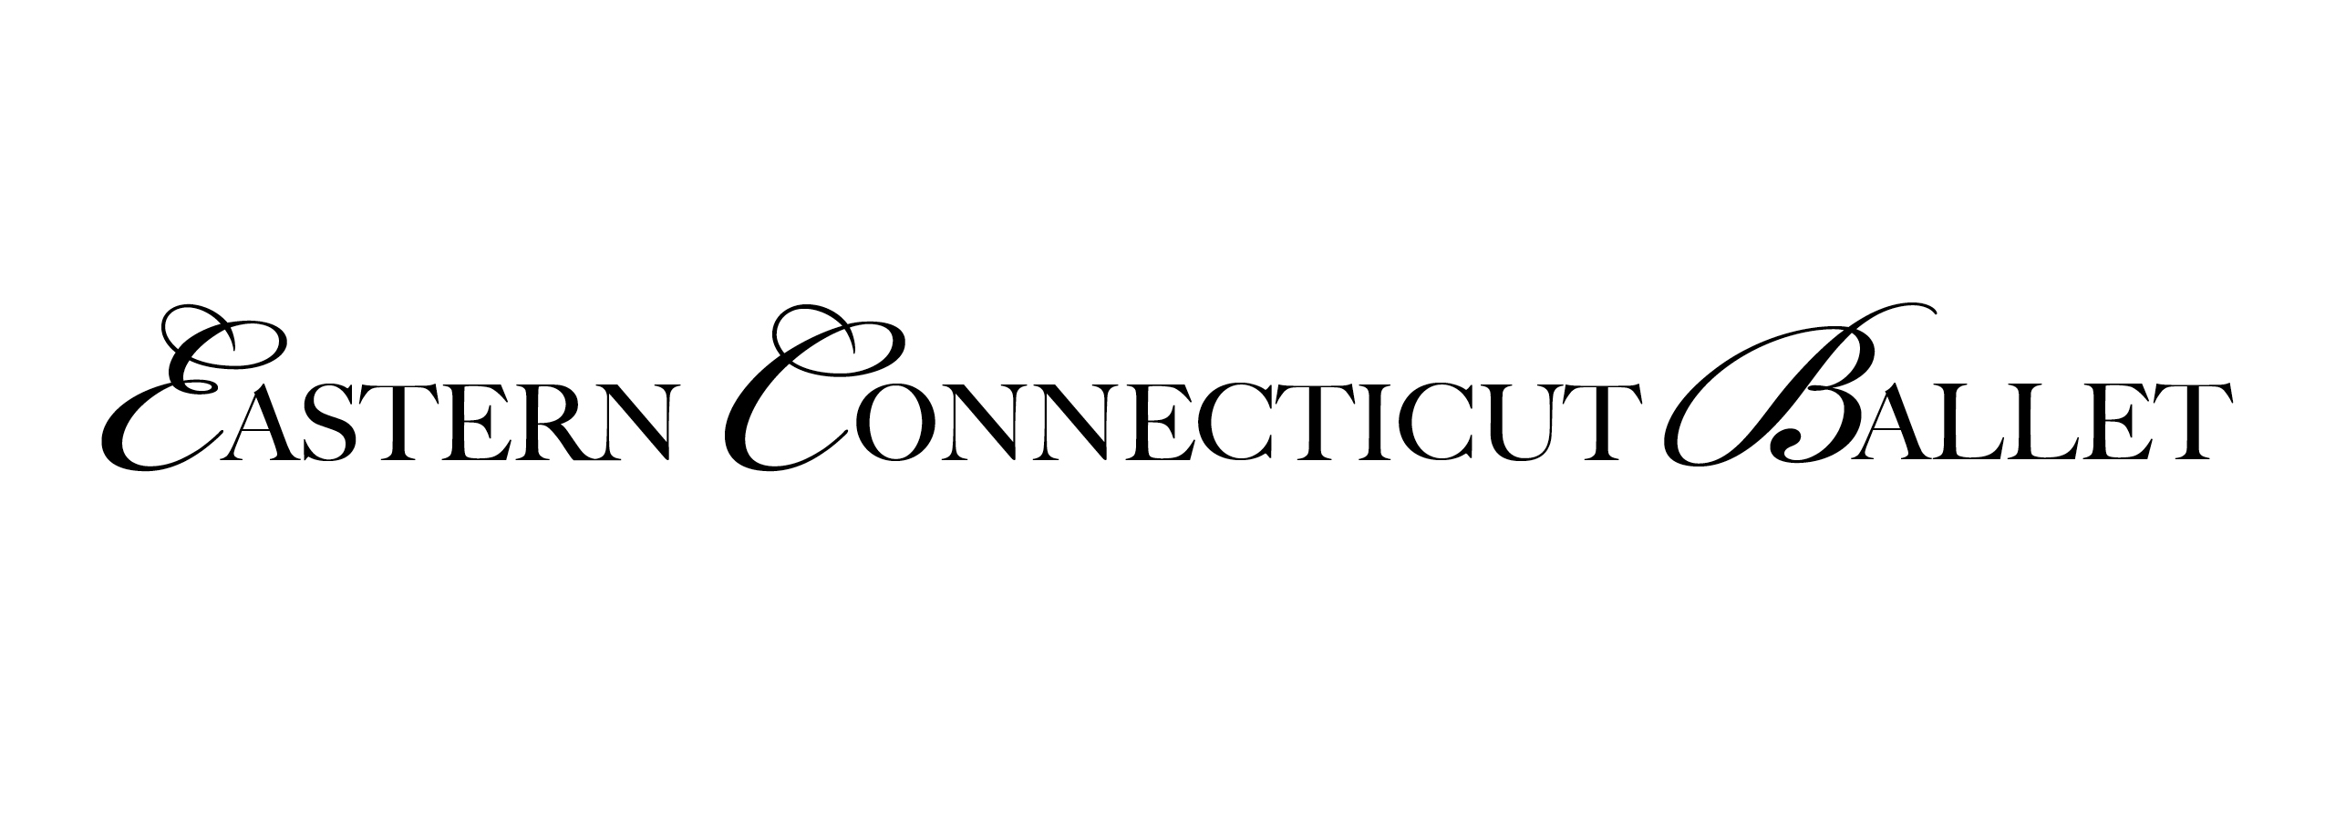

______________________________________________________
October 2017

Dear Parents and Students:

We are pleased to invite you/your child to participate in ECB’s Spring Showcase. This is a wonderful opportunity for students to share their talents with family and friends.

This letter contains important information about the event. We will communicate again as soon as more details become available. Please retain it for reference.

DATE: SATURDAY MAY 26 & SUNDAY MAY 27, 2018
Sunday May 27 1:30pm
BARN DANCE-
Includes all Children’s A-D classes, Character ½, Character ¾, Tap/Jazz D/1, Tap/Jazz 2/3
+
Company Rep

Saturday May 26 7:30pm
Levels 1-7 Ballet Pieces,
Modern 5, Modern 6A/6B, Modern 7, Character 5/6A
+
Company Rep

LOCATION: Valley Regional High School
Deep River, CT

** Please Note: as of Nov 1 (Costume Deposit Date) the class (day/time) that you enroll in will be the class you will remain in for the duration of the year. No switching or swapping classes will be allowed.
Level 1 dancers must commit to ONE section (no split section will be allowed)**

We all recognize that it is important for the dancers to be well rehearsed so they look and feel good on stage. Therefore, it is necessary for students to make every effort to consistently attend their regularly scheduled classes and rehearsals. A performance is an individual AND team effort. We often hear parents say it is “OK” for a child to miss rehearsal because she knows her dance. Unfortunately, one dancer’s absence impacts the effectiveness of the entire group. There is nothing more lovely than a “corps” that moves and breathes as one. Dancers must work together to reach this goal. It is never too soon to participate in an educational experience that teaches respect, cooperation, teamwork, and the joy of success that results from hard work.

REHEARSALS: will commence on Feb 5, 2018 in Class

* Children’s A, B, C & D Mandatory rehearsals Sunday, May 6 & 20 (1:30-3:30) and In Class
* Level 1 Saturday, May 19 & In Class
* Level 2 Saturday, May 19 & In Class
* Level 3 Saturday, May 19 & In Class (Mon., Thurs.)
* Level 4 Saturday, May 19 & In Class (Mon., Thurs.)
* Level 5 Saturday, May 19 & In Class (Tuesday, Saturday)
* Level 6A Saturday, May 19 & In Class (Tuesday, Saturday)
* Level 6B Saturday, May 19 & In Class (Saturday)
* Level 7 Saturday, May 19 & In Class (Saturday)

* Tap/Jazz Mandatory rehearsals Sunday, May 6 & 20 (1:30-3:30) and In Class

* Modern, Character 5/6A Saturday, May 19 & In Class

*Character 1/2 and 3/4 Mandatory rehearsals Sunday, May 6 & 20 (1:30-3:30) and in Class

*Company Rep Saturday, May 19 & Regular company days and times
(Tuesday 5:30-6:30, Friday 4:30-8:30 & Saturday 10:30-?)

The week before the performances, May 21-26, is Tech Week. There will be NO classes held at ECB. Dancers must be available every day, Monday-Friday, from 3:30-9pm and Saturday, 10-3:00pm. They will not be needed every day but must be on call, until the Tech Week Schedule is mailed out. We will send out a tech week schedule by late-April/early-May. These rehearsals, depending on the day, may be held either at Valley Regional High School or at ECB. Please pay careful attention to the location of rehearsals.

REMEMBER:
Participation in the Spring Showcase is NOT mandatory. Even though many rehearsals are held in class the material studied is part of the curriculum. All students will benefit from learning the choreography even if they are not performing.

FEES:
A costume fee will be charged to each dancer. A costume deposit of $35.00 will be assessed, per each piece, your child will perform in. This fee will be due Nov 1 and is NON-REFUNDABLE. We will make every effort to be cost-conscious. The costumes are yours to keep. All dancers must supply their own tights, shoes and make-up. A measurement chart has been enclosed to assist us in ordering costumes. Please take your child’s measurements as listed and fill in the appropriate figures. We will let you know your final costume fee balance once costumes have been selected and ordered. You will receive a bill at that time.

An ECB Professional Quality make-up kit (if you do not already have the ECB make-up kit from previous ECB productions) will need to be purchased by each dancer/family. This keeps the performances uniform and will be used for all future ECB performances. (A ONE TIME PURCHASE of $65.00.)
Make-up for A-D - Cheek powder, Mascara, & Lip Color (fee $20.50). FIND FORM ENCLOSED.

Tickets will go on sale March 26th. You may purchase tickets at ECB.

If your child would like to participate in this performance please indicate by signing below and returning the enclosed forms and per piece costume deposit to ECB no later than November 1, 2017.

Sincerely,
ECB Faculty

THIS FORM and COSTUME DEPOSIT IS DUE: November 1, 2017

*****************************************************************************

YES-
I, __________________________________ will be able to participate in the “Spring Showcase”. I understand that this will require a commitment of time and effort and I agree to participate fully in ALL classes and rehearsals.

____________________________ ______________________________
Parent Signature Dancer Signature

Please write in the class piece you will participate in: All Ballet, Modern, Character

Class Level ______________________________Day _____________ Time _____________ Deposit $35.00
Class Level ______________________________ Day _____________ Time _____________ Deposit $35.00
Class Level ______________________________ Day _____________ Time _____________ Deposit $35.00
Class Level ______________________________ Day _____________ Time _____________ Deposit $35.00
Class Level ______________________________ Day _____________ Time _____________ Deposit $35.00

YOUR 2nd AND FINAL Costume Balance will be due: JANUARY 15, 2018

_________ Company NO COSTUME DEPOSIT DUE

Casting for Company pieces will be posted at a later date.

*************************************************************

NO-
I, __________________________________ am NOT interested in participating in the “Spring Showcase”. I understand that my child’s class time will be used to put this piece together and will be an enriching educational experience whether performing or not.

